**ASSIGNMENT 35.1**

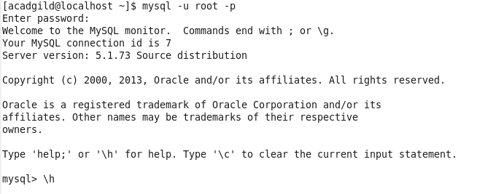

**Create a employee table in Mysql and columns as Emp_id, Emp_name, Dept_name(Hadoop Developer), Emp_sal.**

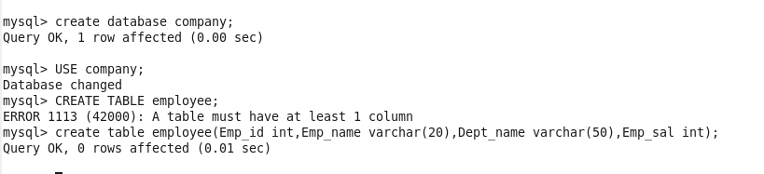

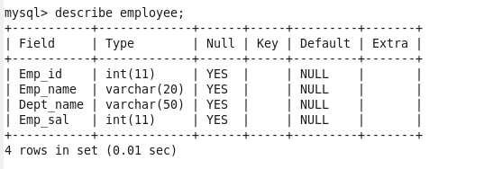

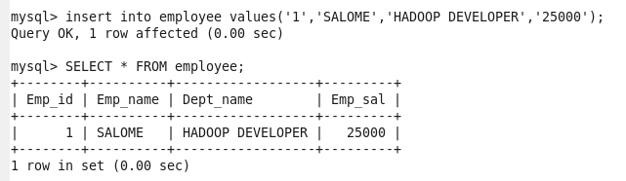

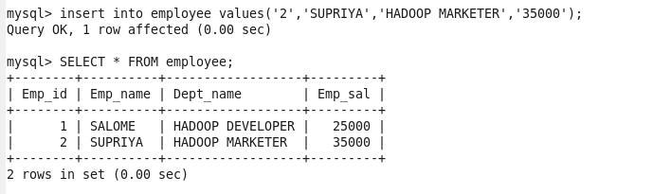

**Import the employee table contents into the HDFS directory using Sqoop.**

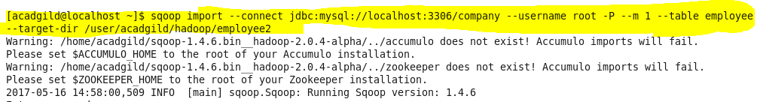

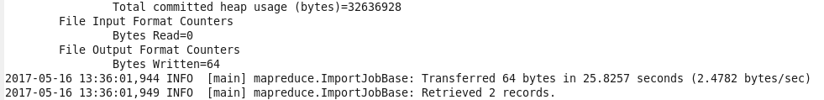

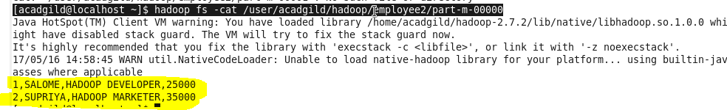

**Create an employee2 table in Mysql**

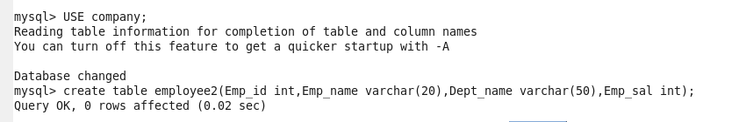

**Export employee details file from HDFS directory to Mysql table employee2 using Sqoop**.

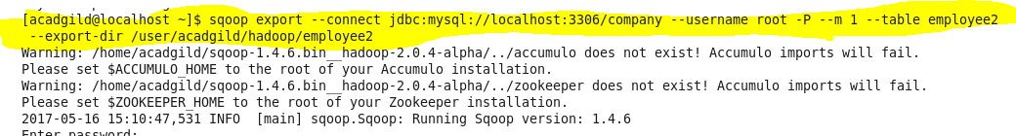

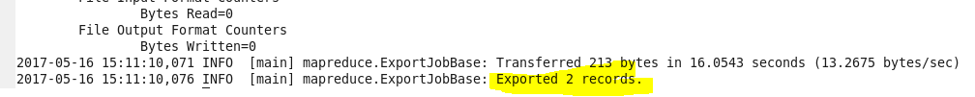

**OUTPUT:**

